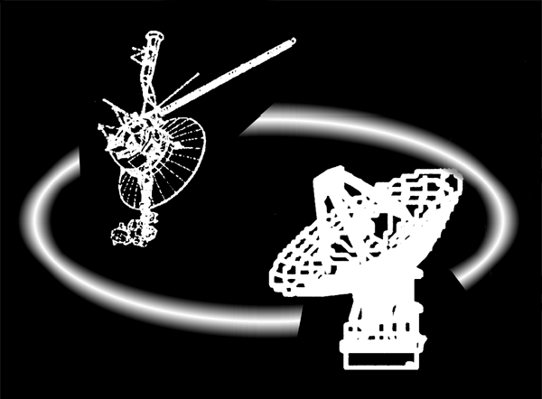
Deep Space Network

Draft_A

Deep Space Network
DSS-28 Development & Deployment Plan

Prepared by:

P. Poon L. Teitelbaum F. Baher N. Bucknam A. Freiley M. Hofstadter T. Kuiper J. Lauf S. Weinreb E. Abrahamy F. Battle J. Leflang

Document Owner:

___________________________________________
Peter T. Poon Date
Telecommunications & Mission Systems Manager

Approved by:

______________________________
Kenneth R. Kimball Date
DSN Engineering Process Manager

DSN No. xxx  Issue Date:  JPL xxx  Jet Propulsion Laboratory  California Institute of Technology | ___________________________  DSN Document Release Date

Review Acknowledgment

Concurred by:

_________________________________________
Wendy K. Hodgin Date
Antenna Front End and DSN Science Support
DSN Development, Operations and Services Program Office

__________________________________________
Charles J. Naudet Date
Deep Space Tracking Systems Group Supervisor

Document Change Log

The requirements and costs in this document will be reviewed, updated, and signed by the Project and DSMS when significant changes are needed and approved.

Revision | Check (X) If Minor Revision | Issue Date | Affected Sections or Pages | Change Summary
Initial Release -Draft Review Version??

Table of Contents

List of Figures

List of Tables

Introduction

1.1 Purpose of DSS-28 Implementation Task
The DSS-28 Implementation Task is designed to provide the Goldstone-Apple Valley Radio Telescope (GAVRT) program with a second radio telescope dedicated to educational activities. This task is following a streamlined approach compared to a normal DSN implementation (with a reduced number of reviews, less formal requirements, and less extensive documentation), reflecting the flexible nature and limited funding of GAVRT. The implementation has three high-level objectives:
- Support anticipated growth in the number of teachers involved in the GAVRT program.
- Support new science experiments, which tie to new educational requirements.
- Provide a more reliable antenna.

1.2 Scope of the DSS-28 Implementation Task
The DSS-28 Implementation Task will take the DSS-28 antenna from its current status (moth-balled and missing many key components) to a fully functioning data collection system for teachers in the GAVRT program. This includes the mechanical restoration of the antenna (including modifications necessary to adapt to a redesigned microwave system), restoration or creation of all hardware and software to properly control the antenna, creation of all components of the microwave system (feeds, front- and back-ends), and upgrades/creation of the station infrastructure (such as power and internet connections) needed to support GAVRT operations. The implementation will also provide spare hardware and plans for proper maintenance of DSS-28, consistent with the requirements and risk-posture described later. In addition to these traditional DSN activities, the DSS-28 Implementation includes training of operators at the Lewis Center for Educational Research (LCER, JPL's educational partner in GAVRT), and the development of teacher training and classroom material necessary for educators to take full advantage of the DSS-28 instrument.

1.3 Scope of This Document
This document will reference the DSS-28 requirements and describe the plan used to design, implement, operate and maintain the DSS-28 antenna and all associated materiel. It will present the basic design of the system, formalizing materials presented at the Task's PDCR, later to be updated by results from the PDR/CDR. It will also describe the plan for testing to be done before and after DSS-28 is turned over to LCER for educational operations. It will make reference to, but not describe in detail, the purely educational items developed as part of this task, e.g. classroom lessons; that work is to be performed primarily by LCER, with inputs from JPL as necessary.

1.4 Applicable Documents
1. DSS-28 Implementation Preliminary Definition & Cost Review Presentation, April 14, 2006
2. DSS-28 Implementation Level-2 Requirements, PDCR Presentation, April 14, 2006
3. DSS-28 LCER ACSS and MCS Presentation, PDR/CDR, February, 2007

DSS-28 Implementation Task Overview

2.1 Objectives and Background of DSS-28 Task
The GAVRT program is a partnership between NASA (represented by JPL) and LCER. GAVRT seeks to help educate America's youth by getting students and teachers involved in real scientific research and engineering development. Partnered with professional engineers and scientists, students make measurements and collect data which are used to study astronomical objects and improve the instruments used in that work. (For example, GAVRT has helped calibrate the radiometer aboard the Cassini spacecraft, and has advanced our understanding of quasars and the interstellar medium.) The GAVRT project began in 1996, and has been successful using the DSS-12 antenna to excite students, teachers, and scientists around the world.
In 2003, it became apparent that the success of GAVRT would eventually cause it to outgrow DSS-12, and NASA committed itself to providing GAVRT a second, dedicated telescope. The three growth areas were mentioned in Section 1, and are here expanded upon:

- Support anticipated growth in the number of teachers and students involved in the GAVRT program. The addition of DSS-28 as a telescope dedicated to GAVRT's use should provide enough tracking time to meet teacher's requests into the next decade.
- Support new experiments, which tie to new educational requirements. GAVRT requires enthusiastic scientists and engineers to support existing activities and to develop new ones. New activities are crucial to maintain teacher and student interest over the years, and to address evolving educational standards. The DSS-28 Implementation will provide new, cutting-edge capabilities that will engage scientists, engineers, educators, and students.
- To provide a more reliable antenna. The DSS-12 telescope, operated 24-hours per day, 4.5 days a week, is showing its age. Numerous equipment problems have resulted in many lost tracking hours, and it has become very difficult to maintain its obsolete equipment. The result has been a degradation in our ability to support teachers, and a severe drop in the scientific value of data collected. The DSS-28 implementation will provide a more reliable telescope that is easier to maintain.

2.2 Key Requirements and Constraints
The following DSS-28 Level-1 and Level-2 requirements and constraints are provided in Reference 2, which also includes assumptions and more detailed explanations.

2.2.1 DSS-28 Level-1 Requirements
The major intent behind the development of the second telescope is to deliver to GAVRT an instrument providing the best sensitivity over the largest range of frequencies, given the financial and technological constraints. Possessing such an instrument will not only support the observation campaigns currently supported by DSS-12 but also allow GAVRT to support ambitious new observation campaigns to support LCER’s curriculum. With this intent in mind, Level-1 requirements have been negotiated between IND and LCER to provide guidelines in the development of the second telescope:

1. The proposed second telescope to the existing GAVRT project shall support anticipated program growth.

2. The proposed second telescope shall provide observational capability sufficient to perform publishable research with data quality at least equivalent to:

- DSS-12 for existing observation campaigns
- DSS-13 for Cassini-JMOC

3. The proposed second telescope shall support the following observation campaigns:

- Jupiter Quest
- Uranus
- Quasar Variability Study (QVS)
- Mars Radar
- Microwave spectroscopy of methanol masers
- Interferometry (at frequencies instrumented for single-dish programs)
- SETI (Lower priority)
- Pulsar timing (Lower priority)

2.2.2 DSS-28 Level-2 Requirements

See Reference 2 DSS-28 Functional Requirements Document

2.3 DSS-28 Functional Block Diagrams

Functional Block Diagrams (A. Freiley)

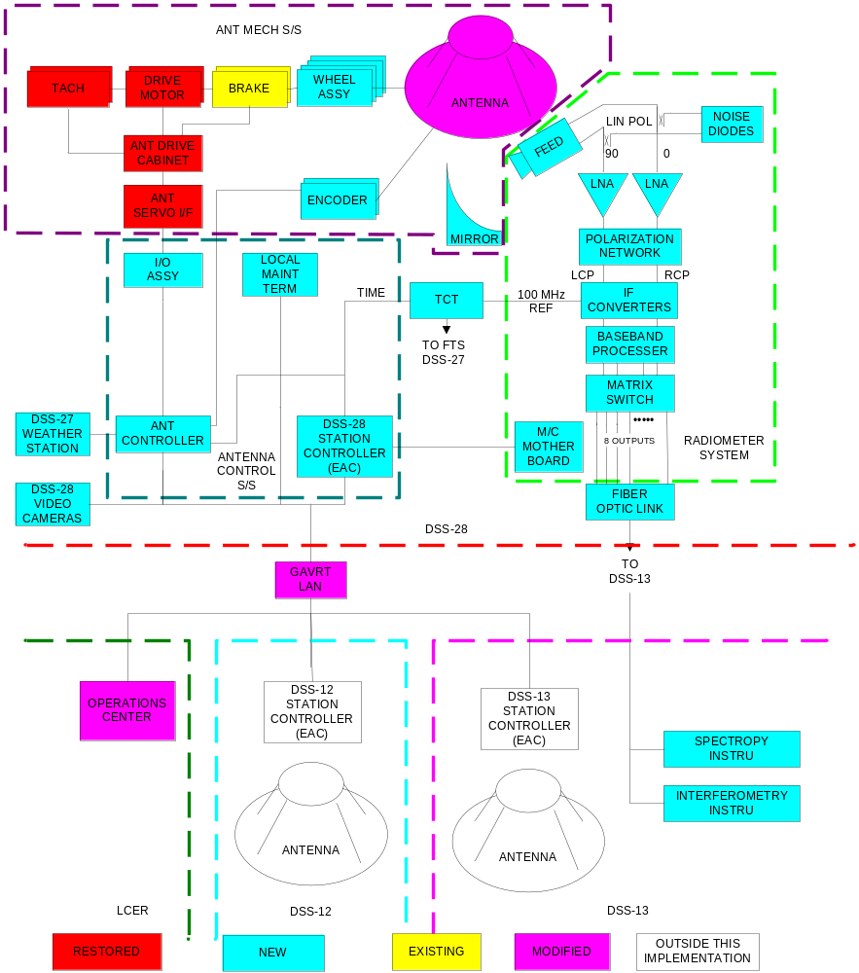

Appendix B presents the detailed DSS-28 System Block Diagram provided by Farrokh Baher based on inputs from the team members.

2.3.4 Responsibility Changes at End of Task
At the end of the DSS-28 implementation task and after delivery of DSS-28 to Lewis Center for Educational Research, the implementation responsibilities will be replaced by the following:

- A core JPL DSS-28 Management and Engineering team will continue to provide management interface to LCER and to provide technical advice on all aspects of DSS-28
- LCER will continue to provide management interface to JPL
- LCER will assume operations responsibilities of DSS-28 including curriculum development and LCER operator training
- JPL/ Goldstone will provide maintenance of DSS-28

DSS-28 Implementation Plan

DSS-28 Implementation planning includes the following:

- Development of Work Breakdown Structure (WBS)

  - Cost categories: JPL Labor, P/M, P/S

- Development of preliminary integrated schedule

- Obtaining cost estimates from technical leads

- Time-phased labor, procurements, subcontracts consistent with integrated schedule

- Estimation of costs using JPL Project Cost & Analysis Tool (PCAT)

  - Apply full JPL burden and business model to JPL-funded expenditures

  - Bypass LCER-funded expenditures

- PCAT cost walkthroughs with owners of cost elements to confirm time-phasing, establish consistency, secure commitment of doing organizations

All of the above items have been completed for DSS-28.

DSS-28 Project Organization Chart

Project Manager
Larry Teitelbaum
GAVRT Lead Scientist
Mark Hofstadter, Uranus
LCER Director of Global Prog Dave Maclaren

Engineering / Mgmt Team
Art Freiley, Project System Engineer
Peter Poon, TMS Manager
Mike Britcliffe, I&T Engineer
GAVRT Science Team
Steve Levin, Jupiter Quest, SETI
Dayton Jones, Interferometry
Tom Kuiper, Microwave Spectroscopy
Dave Jauncey, QVS

Curriculum Development & Ops Training

AMR
Neil Bucknam
BESS
Tom Kuiper
ACSS
John Leflang
Farrokh Baher

RSS
Sandy Weinreb
FTS
John Lauf
MCSS
John Leflang

Contributed Cost
Costed to the project

3.1 Antenna Mechanical Restoration
Phase I Summary and Schedule (AMR)

- Disassemble, clean and paint removed DSS-27 azimuth trucks. Grease and store for installation in early calendar '07
- Clean-up and paint drive motors & gearboxes as necessary. Store in pedestal in preparation for early calendar '07 installation.
- Inventory usable Wheel Assembly hardware at DSS28. ITT to procure missing, damaged or unusable pieces to support installation and have on hand by the time of installation.
- AMR installation for DSS 28 is dependant on the installation of DSS 27 wheels. Although 27’s wheels are due in November of ’06 (DSS 28’s due in December ’06) a downtime for DSS 27 must be negotiated and metrology equipment is not expected back from overseas until late February of ’07. Use of equipment such as cranes and lifts will be used on both DSS 27 and DSS 28 implementations. Based on these still fluid discussions it is expected that the downtime will be in March of ’07 and resources with ITT and JPL resources being committed to a DSS 27 installation first and DSS 28 to immediately follow.
- ITT to determine if drive amplifiers used as hot spares have been replaced at DSS 28 and if not, complete the replacement by installation time. JPL requires that the antenna is able to be moved sufficiently by 'antenna slew pots' to verify drive operation and conduct alignments.

Support from ITT during Installation, early '07.
- Arrange for a crane to support the wheel installation at DSS 28.

- Provide support for assembly and installation of trucks and drive motors (with JPL).
- Provide alignment support for drives and encoders (with JPL).
- Check & lubricate EL bearing & drive system, molykote (ITT Burden effort).
- Wire wheel Az track & molykote (ITT Burden effort)
- Paint antenna and catwalk handrails international orange.
- Procure 4"X 1/4" mild-steel for kickplates to be added on catwalk, approximately 300 linear feet. Weld kickplates between vertical handrail support and paint.
- Procure and fit chains (3/16" with snaps, 100' should do) and safety signs (same as DSN BWG convention) to the catwalk and antenna ladders/stairways.
- Inspect and replace liquitite conduit at drive motors and other critical locations suffering from weathering damage.

Phase II Summary and Schedule (AMR)

Phase II summary and schedule pending combined PDR/CDR in January of ’07.

3.2 Radiometer Subsystem (RSS)
The overall RSS implementation plan is for design, assembly, and testing to be performed by the Caltech Electrical Engineering Department by subcontract to LCER supplemented by JPL support of S. Weinreb. Caltech will supply graduate student and technician support, purchasing of components under $2000, vendor selection and specifications for purchase of components over $2000 by LCER, and subcontracted machine shop service.

RSS Deliverables (and Dependencies)

Presentation material for PDR Jan 15, 2007
Prototype feed/LNA test data ,
RSS block diagram
RSS specifications
RSS M/C signal interface control document Mar 15, 2007
S/C/X/Ku Receiver
Front-end delivery to DSS28 July 1, 2007
(Need tertiary, cryo, and M/C test functions) July 15, 2007
Aeff and Tsys test data report Oct 1, 2007
System RF integration complete with full test report Jan 1, 2008
(Need spectrometer including software) Nov 1, 2007
Spectrometer integration test report May 1, 2008
System operational June 1, 2008
L/S Receiver
(Go/No-go decision; result: Go) Feb 1, 2007
Delivery to DSS28 Jan 1, 2008
Aeff and Tsys test data report March 1, 2008
RF integration complete with full test report May 1, 2008
Spectrometer integration complete July 1, 2008
System operational Sep 1, 2008

3.3 Frequency and Timing System

The Timing Subsystem CDE shall:

Design a feasible and cost effective method of providing frequency and timing signals to users at DSS-28 based on the requirements as described in the GAVRT-II PDCR and/or in direct consultation with the CDEs of the following subsystems:

Sandy Weinreb RSS
Farrokh Baher ACSS
John Leflang ACSS & MCS
Tom Kuiper BESS

Provide a budget estimate and delivery schedule to the GAVRT-II Task Manager based on the proposed subsystem design.

Procure the necessary hardware in order to implement the proposed design.

Test the hardware to be delivered in accordance with released test procedures.

Deliver the hardware to the cognizant Goldstone engineers with installation instructions as appropriate.

Verify the frequency and timing subsystem performance after completion of the installation at DSS-28.

Provide rack and interconnection drawings that will facilitate installation of the hardware and subsequent fault diagnosis, by Goldstone engineers.

Support connection of users to the FTS hardware and resolve any interface issues that may arise between FTS and user hardware.

FTS Subsystem Delivery Schedule

 | Milestone | Date
1. | Provide high-level design and cost estimate | Jul. 2006
2. | Procure hardware and cables | Sep. 2006
3. | Deliver hardware and cables to GDSCC | Oct. 2006
4. | Installation testing | Feb. 2007
5. | FTS – User integration | 2007 - 2008

Table x.x FTS Subsystem Implementation Schedule

3.4 Antenna Control Subsystem and Monitor and Control Subsystem

The DSS-28 Antenna Control Subsystem consists of

- the Antenna Drive Assembly for which JPL is responsible, and

- the LCER Antenna Control Assembly for which LCER is responsible

LCER is also responsible for the implementation of DSS-28 Monitor and Control Subsystem.

See Reference 3

3.5 Back-End Subsystem

The Back End Subsystem CDE shall:

Design a feasible and cost effective method of performing signal spectrum analysis to users at DSS-28 based on the requirements as described in the GAVRT-II PDCR and/or in direct consultation with the CDEs of the following subsystems:

Sandy Weinreb RSS
John Lauf FTS

Provide a budget estimate and delivery schedule to the GAVRT-II Task Manager based on the proposed subsystem design.

Advise the Lewis Center for Educational Research (LCER) on the procurement of the necessary hardware in order to implement the proposed design.

Test the hardware to be delivered in accordance with standard test procedures.

Arrange for the acceptance of the hardware by the cognizant staff with installation instructions as appropriate.

Verify the Back End Subsystem performance after completion of the installation at DSS-28.

Provide rack and interconnection drawings that will facilitate installation of the hardware and subsequent fault diagnosis.

Support development of software for users of the BESS hardware.

Resolve any interface issues that may arise between BESS, the RSS, and the TSS.

 | Milestone | Date
1 | Provide high-level design and cost estimate | Jan. 2007
2 | Negotiate specifications with LCER and potential suppliers,  and place order | Sep. 2007
3 | Deliver hardware and cables to GDSCC | Dec. 2007
4 | Installation testing | Jan. 2008
5 | BESS – User integration | Dec. 2008

DSS-28 Design and Development Approach

The DSS-28 Design and Development Approach consists of the following:

- The design and development approach is design-to-cost because the task is cost-capped

- The design approach emphasizes design inheritance and streamlining

- JPL, in partnership with LCER, is responsible for the overall management of the DSS-28 task.

- JPL provides technical direction of detailed engineering and design and is responsible for overall integration and test of DSS-28.

- LCER is responsible for the design and implementation of the Antenna Control Assembly and the Monitor and Control Subsystem.

- JPL is responsible for preparing subcontracts and procurement packages.

- LCER is responsible for carrying forward major procurement actions and for subcontracting with no additional cost to the task.

A Requirements Compliance Matrix has been generated.

It lists the requirements, their values where applicable, the status of compliance and the verification method for each requirement.

The Requirements Compliance Matrix is provided in Appendix A.

DSS-28 Procurement

Neil Bucknam AMR Sandy Weinreb RSS
John Lauf FTS Farroh Baher ACSS
John Leflang ACSS & MCS Tom Kuiper BESS

Planned major procurements (> $ 100K), including contracted work

Types of procurement and estimated dollar value

Documentation associated with the procurement,

e.g. SOW, RFPs

QA Approach

GFE items (if any) that must be supplied to the vendor

5.1 DSS-28 Procurement - AMR

Planned major procurements (> $ 100K), including contracted work

Phase I procurements/subcontracts

Lewis Center procuring DSS 27 wheels, estimated at $130K
Encoder mount modifications, Az and El. JPL fab, $9K
ITT TDR for effort described in Implementation Plan above estimated at $70K

Documentation associated with the procurement,
e.g. SOW, RFPs

QA Approach
QA Ceritifications will be provided by wheel manufacturer.
ITT QA will responsible for quality and inspection of re-assembled drives and installation

5.2 DSS-28 Procurement - RSS
Major procurements
Caltech sub system engineering July 1, 2006 $115K
Caltech sub system assembly and test July 1, 2007 $120K
S/C/X/Ku front-end components Feb 1, 2007 $50K
8 Downconverter components Apr 1, 2007 $120K
Integration components (photonic) Aug 1, 2007 $50K
L/S front-end components May 1, 2007 $50K
IF Spectrum Analyzer Mar 1, 2007 $20K
IF Switch Matrix Sep 1, 2007 $50K

All of the above will be direct purchase orders from LCER with the exception of components under $2K which will be purchased by Caltech charged to the engineering contract. Approximately 20 purchase orders from LCER are anticipated. Components will be commercial quality and inspected, as required, by Caltech.

- 3 DSS-28 Procurements - FTS

The Timing Subsystem CDE shall procure/provide the following hardware and cables:

- Multimode fiber optic tails to be spliced to the backbone fiber between DSS-27 and DSS-28. [Note: A DSN standard, armored, 62.5/125u, 12-fiber cable for use as the backbone between DSS-27 and DSS-28 has been installed by GDSCC personnel.]

- 4-fiber, plenum rated fiber optic cables for the user TCTs to be located in the DSS-28 pedestal.

- Timing System Distribution Amplifier capable of supplying signals to 10 users in the DSS-28 pedestal.

- Time Code Translators (not to exceed 10) as required by users in the DSS-28 pedestal.

- Time Code Translator plug-in modules as required by users, to provide any of the DSN standard time codes, pulse rates or frequencies currently defined in JPL document DSCC Frequency and Timing Subsystem Design, 835-002.

- Fiber optic splice trays, cable trays and connectors as required to complete the FTS installation.

- At least 10% sparing shall be provided for all FTS modules.

User Cables - Provision of cables (co-ax and multi-conductor) between TCTs and user equipment is the responsibility of the user CDE for each respective user subsystem.

5.4 DSS-28 Procurement – ACSS & MCS

For the Antenna Drive Assembly (ADA):

Hardware already purchased:

Encoders, redundant power supply, cable, interface card: Estimated at $23.4K
Limit switches: estimated at $1.7K

Remaining hardware to purchase:

Cables: Estimated at : $10K
Power Supplies: estimated at : $1.6K
Misc: Estimated at $2.0K

See Reference 3 for LCER procurement

5.5 DSS-28 Procurement - BESS

The Back End Subsystem CDE shall advise the LCER on the procurement of or provide the following hardware, firmware, and software:

A to-be-determined number of processor boards, with one real or complex baseband input for each of the two orthogonal polarizations, with bandwidth matching that of the RSS channels.

One or more chassis with power supplies to hold the processor cards.

Vendor-supplied firmware to both auto-correlate and cross-correlate the two signals entering each processor board.

Assuming that at least two processor boards are procured, there will be no spares, as longer as the vendor can repair or replace failed units.

LCER or JPL developed software to control and read the BESS and store data on disk.

As a backup or low-cost de-scope option, a switch network to provide access to the VLBI Science Receiver (VSR) at DSS-13, since all inputs to the current DSS-13 IF switch are committed.

Standard radio astronomy spectral line processing software .

IF Cables - Provision of switches and cables between the RSS and the BESS is the responsibility of the RSS CDE.

Configuration Management

Requirements

The requirements were developed during the negotiation between the GAVRT lead scientist with inputs from the lead scientist of each campaign and the GAVRT second telescope implementation task manager with proposals from the lead engineers for each subsystem. The requirements were agreed to between the GAVRT Lead Scientist and the Implementation task manager. The requirements are managed by the following process. A request for requirements change is received and evaluated. If a change is recommended, a change is proposed to the LCER Director Global Operations the GAVRT lead scientist and the implementation task manager. If there is agreement on the change within the science objectives, implementation cost constraints and schedule constraint, the revised requirement is accepted and the requirements are changed officially.

Hardware

For the development of new hardware the design is under configuration control only after the prototype design and hardware are tested and performance data is analyzed, review and accepted as meeting the requirements. At that point in the development the design is placed under configuration control and any significant changes will have to be purposed to the LCER Director Global Operations, GAVRT lead scientist and the implementation task manage for concurrence considering system performance, cost constraints and schedule impacts. If they agree, then the design will change and considered under configuration control.

Software

The software will be placed under configuration control after the controller hardware and software are successfully demonstrated during the prototype development and testing. At that time the software and controller hardware designs and code are placed under configuration control for the final resolution of the anomalies leading up to the beginning of final installation, integration and test (assemble, subsystem and system). At that point in the development the design, software code and hardware are under configuration control and any significant changes other than the resolution of documented anomalies will have to be purposed to the LCER Director Global Operations, GAVRT lead scientist and the implementation task manage for concurrence considering system performance, cost constraints and schedule impacts. If they agree, then the design will change and considered under configuration control.

Product Documentation

List all documents and drawings to be produced with scheduled dates of Completion

Inputs to 7.0, 8.0, 9.0 11.0 to be provided (where applicable) by:

Neil Bucknam AMR Sandy Weinreb RSS
John Lauf FTS Farroh Baher ACSS
John Leflang ACSS & MCS Tom Kuiper BESS

7.1 Product Documentation - AMR

377-15-01-03-G | Bearing Mount
377-15-01-04-G | Encoder Mount
377-15-01-06-G | Encoder Cover
377-15-01-13-G | Encoder Support
377-15-10-15-G | Conduit Holder
SHST-200 | Split Hub Coupling
CL7SS | Collar Clamp
CL9SS | Collar Clamp
571924 | ZBR 2015 Flg Brg
92240A541 | 1/4-20X7/8" LG HEX HD SCR
92240A624 | 3/8-16X1" LG HEX HD SCR
92240A537 | 1/4-20X1/2" LG HEX HD SCR
92240A029 | 1/4" LOCKWASHER
92146A031 | 3/8" LOCKWASHER
93075A153 | 6-32X1" LOG HEX
92146A540 | 6-32 LOCKWASHER
93075A146 | 6-32X3/8" LOG HEX
92000A116 | M3X6mm LG PHIL
9625190 | Azimuth Encoder, Enclosure
9625192 | Azimuth Encoder, Plate
9625191 | Azimuth Encoder, Adjustable Mount
9625193 | Azimuth Encoder, Bearing Mount
9625188 | Azimuth Encoder, Arm Support

7.2 Product Documentation – RSS
For each major assembly there will be a manual which the information required for installation, operation, and maintenance. Each manual will contain: a) block diagram b) circuit schematics, c) interface connector pin-outs and function, d) interior photographs, e) bill of material, f) mechanical drawing list, and g) test data. The major assemblies are:

S/C/X/Ku front-end assembly
L/S front-end assembly
Receiver box
Switch matrix
Power supply box

Spares List - RSS

One LNA of each type (S/C/X/Ku and L/S)
One Downconverter module
One Power Supply Box
One Cooling Head
One Cryo Compressor
One Thermoelectric AC Assembly

7.3 Product Documentation – FTS

All COTS hardware for the DSS-28 GAVRT-II installation is described in JPL document , Time and Frequency Distribution System, Operations and Maintenance Manual, 865-000362.

All JPL designed hardware shall be described in released drawings and/or maintenance manuals.

JPL Drawing 9623592, GDSCC Remote Timing Distribution, Rev. A shows the interconnection between DSS-28 and the GDSCC FTS infrastructure.

JPL Drawing 9605472, Gemini Time Distribution Cabinet Assembly, Rev C shows the hardware source for the DSS-28 FTS signals

JPL Drawing 9605471, Gemini Time Distribution Cable Package, Rev C shows the cable connections for the provision of the System Time Code (STC) to the DSS-28 pedestal.

The DSS-28 pedestal FTS Distribution Amplifier is to be housed in a non-FTS rack (6430/FAC-840).

Cable and hardware installation is described in released ECOs 02.0024 s/s 403.309 and 403.113.

7.4 Product Documentation – ACSS and MCS

See Reference 3.

The documentation for Assembly Drive Assembly (ADA) is as follows:

The following documentations and drawings shall be provided for the DSS 28:

- Antenna overall assemblies block diagram
- Antenna drive assembly and controller interface wiring diagram
- Revise existing drive cabinet drawing to incorporate new changes
- Provide new antenna servo rack drawings
- Servo test procedure, test data and servo performance analysis report
- Release new encoder documentations

Spare List

One encoder for AZ and EL
One limit switch
One 24VDC power supply
One +/-15VDC power supply

7.5 Product Documentation - Back End Subsystem (BESS)

The vendor shall supply an Operating and Programming Manual.

The vendor-supplied hardware shall be described in drawings and/or maintenance
manuals.

A JPL Drawing will show the interconnections between the RSS and the BSS.

A JPL Drawing will show the interconnections between the BESS and TSS.

A JPL Drawing will show the cabling and switches between the RSS and the VSR.

Cable and hardware installation shall be covered by formally approved ECOs.

Product Quality Assurance

List QA activities to be conducted on system/ subsystem-level products,
HW deliverables and SW deliverables.

8.1 Product Quality Assurance – AMR

Neil Buckman to provide inputs HERE

8.2 Product Quality Assurance – RSS

Appropriate for a high quality, ground-based research instrument

By Design – Selection of proven components with sufficient margins
By Implementation – Careful vendor selection and integration by trained personnel
By Testing – Sufficient time and personnel to correct faults in system

8.3 Product Quality Assurance – FTS

All COTS hardware shall be inspected for ID and damage by JPL PQA.

All FTS hardware, both COTS and JPL designed shall be tested to released test procedures at JPL before shipment to GDSCC.

Test data shall be archived by the Timing System CDE.

8.4 Product Quality Assurance – ACSS and MCS

See Reference 3.

For Assembly Drive Assembly, there is no major equipment required to be QA.

By Design - Selection of new AZ and EL encoders based on performance of 12M array antenna.

By Implementation - Using qualified and trained station personnel for installation and testing.

By Testing - Perform sufficient test (during development software of ACSS by LCER engineer) ensure position accuracy.

8.5 BESS Product Quality Assurance

All COTS hardware shall be inspected for ID and damage by JPL PQA.

All BESS hardware, both COTS and JPL designed, shall be tested to released test
procedures at JPL before shipment to GDSCC.

Test data shall be archived by the Back End Subsystem CDE.

Security

There are no special security requirements.

DSS-28 documentation is ITAR controlled.

Safety

Safety - RSS

No voltage above 28V will be employed in the RSS (other than 117VAC primary power)

Installation and maintenance of the RSS will be in center (vertex) of DSS28 with no possibility of falls with the antenna pointed at zenith. Interlocks required to prevent movement of the antenna while it is serviced.

Access to the RSS antenna vertex equipment will be per OSHA standards.

System Safety Checklist

See Appendix C

Facility Modification

11.1 Facility Modification - AMR
Power modifications will be required for Phase II implementation of feed, cryo-compressor, vacuum pump and potential lighting

11.2 Facility Modification – RSS
Installation of a tertiary reflector on DSS28

Mounting of cryogenic compressor and helium lines on DSS28

Mounting of receivers at vertex

One rack in pedestal room for fiber interface and switch to spectrometers

Cabling from DSS28 pedestal room to vertex
One fiber bundle, < 0.5” diameter for LO, IF signals, and M/C
117 VAC 15amp power cable
One cable. 15 shielded pairs for diagnostics, intercom, and maintenance
One cable with > 4 RG-58 type coax for diagnostics
One Eithernet cable

11.3 Facility Modifications - FTS

A new 12-fiber, 62.5/125u multimode cable is required between the timing rack in DSS-27 (5858/FTS-270) and the facilities rack in DSS-28 (6430/FAC-840). This cable is on hand at GDSCC and installation will be covered by ECO 02.0024, 403.113, Rev E.

11.4 Facility Modifications – ACSS & MCS

See Reference 3.

For Assembly Drive Assembly (ADA), there is no new power distribution modification is required for ADA. The existing power is adequate and working fine in the alidade room.

There is a dedicated exiting rack which shall be used to install ASI and interface panel. All obsolete/ old equipment will be removed from the rack in the alidade room

11.5 Facility Modifications – BESS

At least two fibers between DSS-28 and DSS-13 will be assigned for use with the VSR.

Product Delivery

Larry Teitelbaum to provide writeups on the DSN Delivery Review HERE

Maintenance Plan

The maintenance plans are different for the specific major subsystems of the GAVRT antenna (DSS-28). Under the partnership agreement, JPL will arrange and provide all services and DSN sparing for the areas that are common between the 2 HSB antenna (DSS-27 and DSS-28). For those areas that are unique to the GAVRT Antennas and share no commonality with the DSN systems LCER and the ATOT office will call upon the appropriate specialist to effect repairs.

The LCER operators will perform the level “0” monitoring of the system during operations as far as the station controllers are designed to provide error reports and options to sustain continuous operations. For the cases where the operators are unable to continue observations or performance errors are persistent, LCER operations will identify the symptoms, problems and error messages to the DSS-13 staff for level 1 trouble shooting, fault isolation and the determination of the problems area or root cause. If the problems are correctable at this level the DSS-13 staff, with aid of the tools, spares and documentation provided by this implementation task, will effect the appropriate actions to restore the system to operational status and report to GAVRT operations of the corrective actions taken. At that time the operational status should be verified by GAVRT operator before the system is returned to service and the maintenance crew departs the site.

If the problems are beyond the DSS-13 staff’s capability and the root cause of the problem are in the GAVRT unique equipment, the staff will report to GAVRT operations that additional resources are required. LCER and the ATOT office will arrange for the appropriate resources to be dispatched to perform the level 2 maintenance and repair the system. The DSS-13 staff will provide a representative to assist the specialists in these repairs and report to GAVRT operations when repairs are complete.

If the problems are beyond the DSS-13 staff’s capability and/or the root cause is in the areas that are common to the HSB antenna subnet, (i.e. areas that are identical to the antenna’s sister station, DSS-27) the serviced, repair and maintenance will be addressed by the complex maintenance and implementations (M and I) staff. Such items as the antenna with all its structure, drive assemblies, motors, tachometers, safety features (mechanical and electrical) are in this categories. Spares for the antenna in this area will be shared between DSS-27 and 28 on a priority bases favoring the operational station (DSS-27) with the understanding that DSS-28 will not be disabled to supply DSS-27 with replacement parts or assemblies.

Sparing Plan

Spares for the DSS-28 Gavrt 34 m telescope are of 2 classes or types. The first category includes all parts and assembles that are common to the High Speed Beam waveguide (HSB) subnet and the second category is the unique equipment to the GAVRT system.

APPENDIX A
GAVRT DSS-28 FRD Compliance Matrix

GAVRT DSS-28 FRD Compliance Matrix
ITEM # | REQUIREMENT | REQUIREMENT VALUE | COMPLIANCE | VERIFICATION METHOD
1 | S and X-Band Reception | Function | Yes | Design
2 | C and Ku-Band Reception | Function | Yes | Design
3 | Operability | Monitor and Control from LCERFunction | Yes | Design
4 | Blind Pointing | 0.1 beamwidth | Yes | Design
5 | Slewing Rate | 1 deg/sec | Yes | Design
6 | Tracking Rate | 0.25 deg/sec | Yes | Design
7 | IF Center Frequency | 500 MHz | Yes | Design
8 | IF Bandwidth | 1 GHz (0 to 1000 MHZ). | Yes | Design
9 | IF Tuning | Function | Yes | Design
10 | S-band Frequency Range | 2200 to 2400 MHz | Yes | Design
11 | S-band Frequency/phase stability | 4.1 E-13 @ 1 second, 7.2 E-14 @ 10 seconds, 2.9 E-14 @ 100 seconds, 9.1E-15 @ 1,000 seconds | TBD | Test
12 | S-band Sensitivity | = or < 0.006 K in 1 sec (Integration Time) | Yes | Analysis
13 | S-Band Minimum G/T | 40.4 dB @ 45 deg elev | Yes | Analysis
14 | S-band Gain Stability | = or < .0001 in 1 sec | Yes | Test
15 | S-band Polarization | RCP/LCP | Yes | Design
16 | S-band Polarization Isolation | = or > 25 dB | TBD | Test
17 | C-band Frequency Range | 6 to 7 GHz | Yes | Design
18 | C-band Frequency/phase stability | 1 E-14 in 1 to 100 sec | TBD | Test
19 | C-Band Sensitivity | = or < 0.266 K in 5 sec or less with a 5kHz Bandwidth | Yes | Analysis
20 | C-Band Minimum G/T | 47.5 dB @ 45 deg elev | Yes | Analysis
21 | C-band Gain Stability | = or < .0001 in 1 sec | Yes | Test
22 | C-band Polarization | RCP and LCP | Yes | Design
23 | C-band Polarization Isolation | = or > 25 dB | TBD | Test
24 | X-band Frequency Range | 8400 to 8600 MHz | Yes | Design
25 | X-band Frequency/phase stability | + or < 4.0 E-13 @ 1 second, 4.9 E-14 @ 10 seconds, 1.8 E-14 @ 100 seconds, and 5.3E-15 @ 1,000 seconds | TBD | Test
26 | X-band Sensitivity | = or < 0.037 K in 1 sec | Yes | Analysis
27 | X-band Gain Stability | = or < .0001 in 1 sec | Yes | Analysis
28 | X-band Minimum G/T | 52.7 dB @ 45 deg Elev | Yes | Analysis
29 | X-band Polarization | RCP and LCP | Yes | Design
30 | X-band Polarization Isolation | = or > 25 dB | TBD | Test
31 | Ku-band Frequency Range | 11.5 to 14 GHz | Yes | Design
32 | Ku--band Frequency/phase stability | 3 E-8 in 1 to 100 Sec | TBD | Test
33 | Ku-band Sensitivity | = or < 0.023 K in less than 1 hour with a 10 kHz Bandwidth | Yes | Analysis
34 | Ku-band Gain Stability | = or < .0001 in 1 sec | Yes | Design
35 | Ku-Band Minimum G/T | 54.1 dB at elevation angles above 45 degrees | Yes | Analysis
36 | Ku-band Polarization | RCP and LCP | Yes | Design
37 | Ku-band Polarization Isolation | = or >25 dB | TBD | Test
38 | Total Power Radiometer (TPR) | Capability | Yes | Design
39 | Noise Adding Radiometer (NAR) | Capability | Yes | Design
40 | Radiometer Channels | 4 channels | Yes | Design

APPENDIX B
Cost Summary

DSS-28 Cost Estimation Methodology

Basis of Estimate

Cost Summary

De-scope Options

Cost Estimation Methodology

- Developed Work Breakdown Structure (WBS)
  - Cost categories: JPL Labor, P/M, P/S
- Developed initial integrated schedule
- Obtained cost estimates from technical leads
- Time-phased labor, procurements, subcontracts consistent with integrated schedule
- Calculated costs using JPL Project Cost & Analysis Tool (PCAT)
  - Apply full JPL burden and business model to JPL-funded expenditures
  - Bypass LCER-funded expenditures
- PCAT cost walkthroughs with owners of cost elements to confirm time-phasing, establish consistency, secure commitment of doing organizations
Basis of Estimate

- Antenna Mechanical Restoration (AMR)
  - Vendor quotes from recent, identical work at DSS-27
  - Strong heritage from similar work on many DSN antennas
- Radiometer Subsystem (RSS)
  - Vendor quotes for COTs feed horns
  - Recent deliveries under subcontract of CalTech-developed LNAs
  - Strong heritage, leverage of NRE from DSN Array R&D, SuperCAM
  - Strong delivery history for NRAO
- Antenna Control Subsystem (ACSS)
  - COTs hardware, vendor quotes for encoders, control computers, interface boards
  - Strong leverage of RTLinux development and support in open-source community
  - Heritage and leverage of NRE from DSN APC development
  - Strong delivery history for GAVRT
Basis of Estimate (Cont’d)

- Monitor & Control Subsystem (MCSS)
  - Adaptation of existing MCSS used by GAVRT, DSS-13, DSN R&D
  - Strong delivery history for GAVRT
- Back-End Subsystem (BESS)
  - Vendor quote for prototype spectrometer
  - Direct buy of mature, DSN-standard switch
  - Strong heritage, leverage of NRE from JPL Radio Science Receivers
  - Leverage of NRE from current RSR-based software development
- Frequency & Timing System (FTS)
  - Vendor quotes for recent, identical acquisitions throughout DSN
  - Vendor quote for fiber
Cost Summary

- PCAT3_14_DSS-28.pdf follows here!
- Final integrated cost ($K):
FY06 FY07 FY08 Total
$1161.10 $1744.77 $782.34 $3688.21
Time-Phased Color of Money
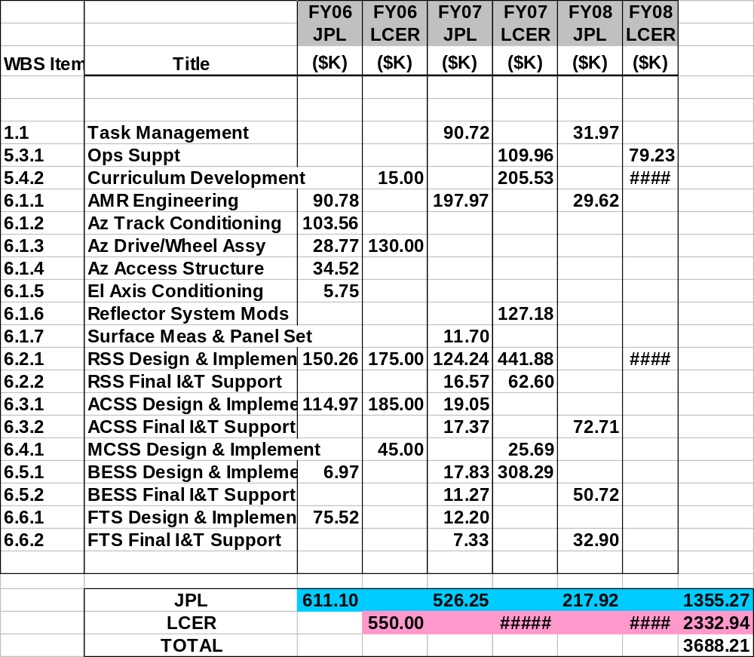

De-scope Options

- AMR
  - Defer Azimuth Track Conditioning: $104K
- Project Management
  - Eliminate Project I&T Engineer $123K
- BESS
  - Eliminate WVSR or Spectrometer $90K
  - Eliminate WVSR and Spectrometer $90K
$3688K minus $407K = $3281K
- After de-scopes, the job approximately fits within the $3.2M committed funding
  - With costed schedule reserve for workforce during final I&T ($271.5K)
  - But otherwise with no reserve

APPENDIX C
System Safety Checklist

